LAMPIRAN

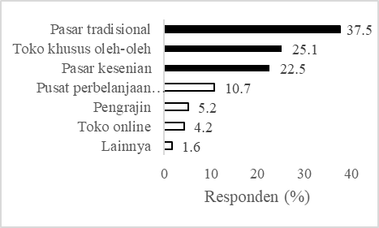Sumber (Source): Data primer (Primary data)

Gambar 1. Tempat pembelian produk anyaman.
Figure 1. The places to buy woven product.

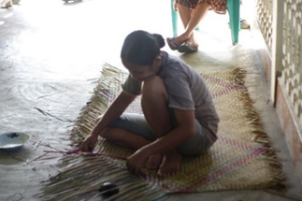
Sumber (Source): World Resources Institute Indonesia

Gambar 2. Tikar Purun Konvensional di Pedamaran.
Figure 2. Conventional purun mats in Pedamaran.

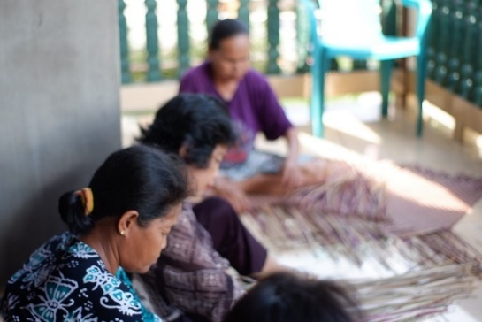
Sumber (Source): World Resources Institute Indonesia

Gambar 3. Kegiatan Menganyam Purun di Pedamaran.
Figure 3. Purun weaving activity in Pedamaran.

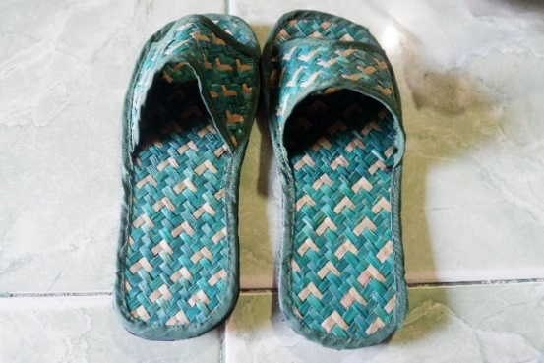
Sumber (Source): World Resources Institute Indonesia

Gambar 4. Sandal purun.
Figure 4. Purun sandals. .

